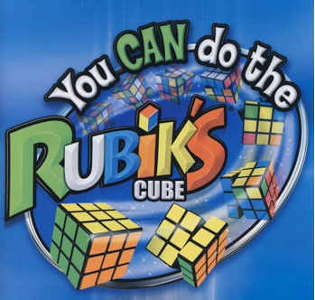

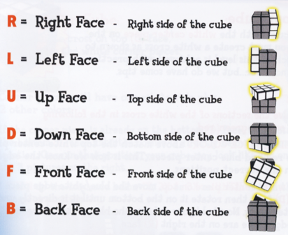

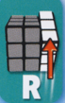 | 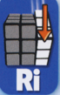 | 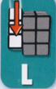 | 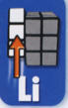 | 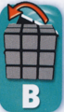
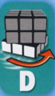 |  | 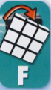

White Cross (White Layer) (Part 1)
Start with white/blue edge in the bottom position on the right side. So on the right side, the white/blue edge piece would be here (with blue on the bottom):
(Remember, this is the RIGHT-facing side.)
W

*Repeat the process with the white/orange, white/green , and white/red edges—in this order.

White Corners (White Layer) (Part 2)
Start a corner piece on the bottom layer lined up directly below where it needs to be moved—so bottom layer with the white on the FRONT face.

So on the front side, the corner cube’s white face is either in the lower right or the lower left of the FRONT face.
If it is here, follow the below sequence:  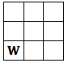 |  | If it is here, follow the below sequence:  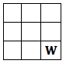
*Repeat the process with the other 3 corners.

 |  | Solve the MIDDLE Layer
 |  | Note: The white face now becomes the DOWN face, while the yellow face becomes your UPPER face.
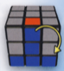 | 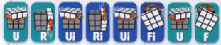
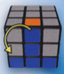 | 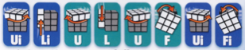

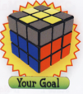 | Solve the TOP Layer…  Get the YELLOW Cross (Part 1)  *Yellow pieces on the top face do NOT need to match the side-pieces, yet.
State 1  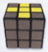 | Proceed to Part 2…
State 2  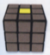 | 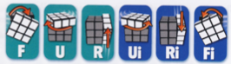  Then match the result to State 3 or 4. Hole the cube to match that State and do that sequence.
State 3  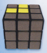 | 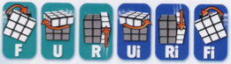
State 4  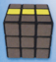 | 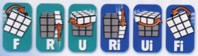

Solve the TOP Layer…
Get ALL the YELLOW on Top (Part 2)
State 1 | NO Corner Cubes are Yellow  You must have a Yellow LEFT Corner on the Left Face as shown—then do the sequence below.
State 2  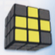 | ONE Corner Cube is Yellow  Match your Top Face as shown—then do the sequence below.
State 3  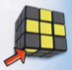 | Any TWO Corner Cubes are Yellow  (Don’t worry about their position)  You must match the front face with a Yellow Left Corner as shown—then do the sequence below.
*Do this sequence 1, 2, or 3 times to achieve a complete yellow top face. After each sequence, ORIENT THE CUBE TO REMATCH THE TOP FACE TO THE APPROPRIATE STATE and repeat the sequence until all corners are yellow.
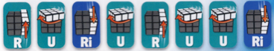

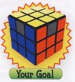 | Solve the TOP Layer…  Position the YELLOW CORNERS Correctly (Part 3)
Looking at the four corners, position 2 corners that are INCORRECT in positions C and D as shown. Do the sequence below.

*IF you still have incorrect corners, hold your cube so the INCORRECT corners are in positions C and D and repeat the sequence below.
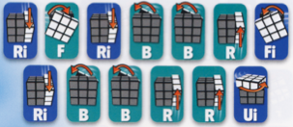

Solve the TOP Layer…
Position the YELLOW EDGES Correctly (Part 4…Final Part)
State 1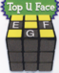 | State 2 |  | *Look closely at your top EDGE pieces.  State 1 is if 3 edge pieces are WRONG and  State 2 is if 4 edge pieces are WRONG.
If you need to rotate your pieces CLOCKWISE in order to fix them, then use this sequence. |  | 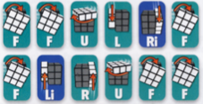
If you need to rotate your pieces COUNTER CLOCKWISE in order to fix them, then use this sequence. |  | 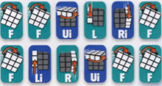

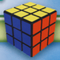
You’ve Solved the CUBE!!!

Now try these other moves…
 | 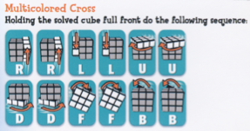
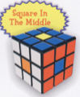 | 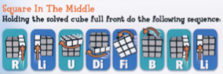
Now go out and teach your friends! You can download the complete directions manual at:

