Graphing Linear Equations Chapter Questions

1. What are the various types of information you can be given to graph a line?
2. What is slope? How is it determined?
3. Why do we need to be careful about the slopes of horizontal and vertical lines?
4. How can we tell is two lines are parallel, perpendicular or neither just from their equations?
5. What are the various ways you can use information given to you to determine the equation of a line?
6. What are the different ways to solve a system of linear equations?
7. When do you get an answer to a system of linear equations that has one solution, no solution and infinitely many solutions?

Graphing Linear Equations Chapter Problems

Tables

Classwork

For the equations below, make a table with at least 3 ordered pairs, plot the points and connect them to form the line.

1. y = 3x - 4
2. y = -2x + 4
3. y = x – 3
4. y = x + 4
5. y = - x + 1

Homework

For the equations below, make a table with at least 3 ordered pairs, plot the points and connect them to form the line.

1. y = -x – 2
2. y = 2x + 1
3. 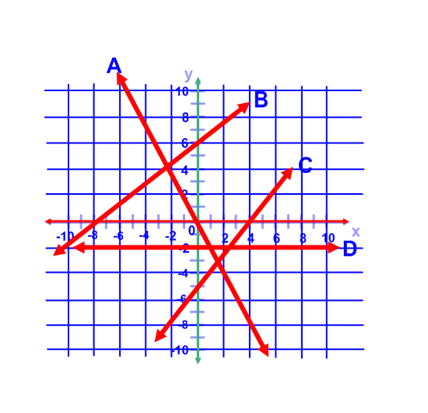y = x
4. y = -2x – 2
5. y = - x + 4

Slope and y-intercept

Classwork

1. Use lines A, B, C and D to fill in the table.

|  |  |  |
| --- | --- | --- |
| **Lines** | **y intercept** | **Slope (+, -, 0 or undefined** |
| **A** |  |  |
| **B** |  |  |
| **C** |  |  |
| **D** |  |  |

1. What is the slope of lines E, F, G and H?

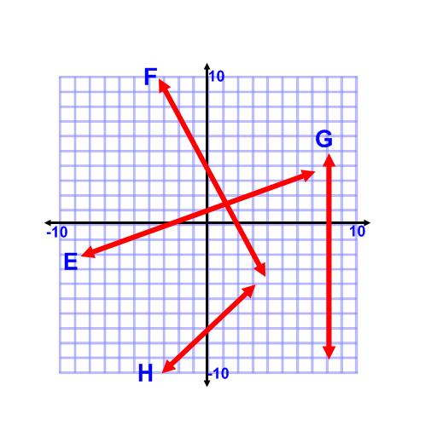

|  |  |
| --- | --- |
| **Lines** | **slope** |
| **E** |  |
| **F** |  |
| **G** |  |
| **H** |  |

1. What are the equations of lines E, F ,G and H?

|  |  |
| --- | --- |
| **Lines** | **Equation** |
| **E** |  |
| **F** |  |
| **G** |  |
| **H** |  |

Homework

1. Use lines I, J, K and L to fill in the table.

|  |  |  |
| --- | --- | --- |
| **Lines** | **y intercept** | **Slope (+, -, 0 or undefined** |
| **I** |  |  |
| **J** |  |  |
| **K** |  |  |
| **L** |  |  |

1. What are the slopes of lines M, N, O and P?

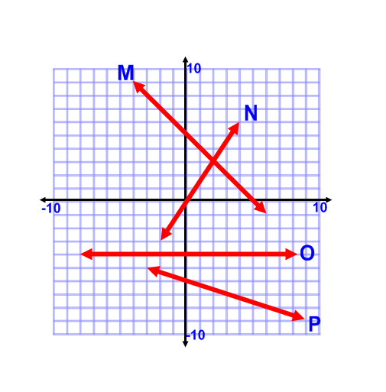

|  |  |
| --- | --- |
| **Lines** | **slope** |
| **M** |  |
| **N** |  |
| **O** |  |
| **P** |  |

1. What is the equation of lines M, N, O and P?

|  |  |
| --- | --- |
| **Lines** | **Equation** |
| **M** |  |
| **N** |  |
| **O** |  |
| **P** |  |

Slope Formula

Classwork Find the slope of the line through each of the following two points.

1. (-12,-5), (0,-8)
2. (12,-18),(11,12)
3. (-18,-20),(-18,-15)
4. (-20,-4),(-12,-10)
5. (8,10),(0,14)
6. (6,9),(3,-9)
7. (1,2),(5,7)
8. (3,-3),(12,-2)
9. (-4,-8),(-1,1)
10. (4,7),(-3,7)

Homework Find the slope of the line through each of the following two points.

1. (3,-9),(1,1)
2. (7,4),(3,8)
3. (-3,0),(5,12)
4. (8,-2),(12,-2)
5. (6,-3),(2,9)
6. (-3,7),(-4,8)
7. (5,9),(5,-8)
8. (-5, 0.5),(-6,3)
9. (-7,1),(7,8)
10. (-2,1),(5,7)

Slope Intercept Form

1. 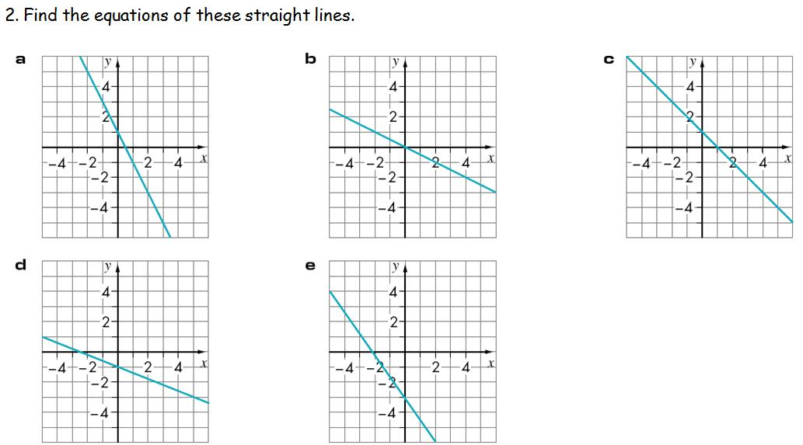Write the equation for each graph that is for the line.

Which graph represents the following equations?

1. y = - 4
2. y = -x + 5
3. y = -3/8x – 6
4. y = 3/2x

Homework

1. Write the equation that represents the following graphs.

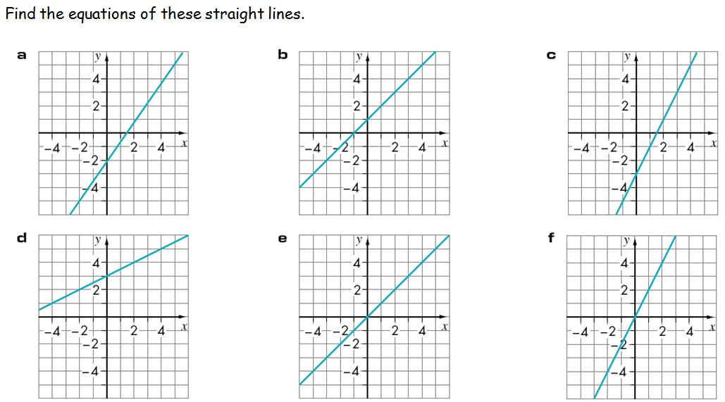

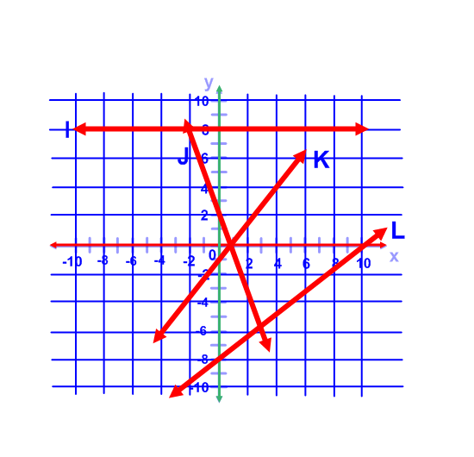

Which graph represents the following equations?

1. y = -4/5 -8
2. y = 8
3. y = 5/4x -1
4. y = -3x + 2

Rate of Change

Classwork

1. If a car passes mile-marker 50 in 2 hours and mile-marker 200 in 6 hours, how many miles per hour is the car traveling?
2. A driver sets the cruise controls at 55 miles per hour. After driving for 3 hours, he passes mile-marker 650. In 2 hours, what mile-marker will he be passing?
3. Dominique earns $10 per hour for tutoring students and is given $15 for gas everyday. Write an equation that represents the situation.
4. Maria spends $200.50 on groceries in a week but earned $4000 total at her last job. Write an equation that represents the situation.
5. John has a company that charges $4/lb. for gourmet candy plus $7 shipping. If Lisa buys 6 lbs. of candy, how much money will she spend?

Homework

1. If a car passes mile-marker 25 in 2 hours and mile-marker 450 in 5 hours, how many miles per hour is the car traveling?
2. A driver sets the cruise controls at 45 miles per hour. After driving for 2 hours, he passes mile-marker 20. In 3 hours, what mile-marker will he be passing?
3. Christina earns $7.50 per hour for tutoring students and is given $50 for gas everyday. Write an equation that represents the situation.
4. Monique spends $400 on groceries in a week but earned $15,000 total at her last job. Write an equation that represents the situation.
5. Timothy has a company that charges $9/lb. for gourmet candy plus $7 shipping. If Janice buys 3 lbs. of candy, how much money will she spend?

Proportional Relationships and Graphing

Classwork

For each problem, draw the graph of the relationship between the two quantities & state what the slope is.

1. A maple tree grows 8 inches each year.
2. Coconuts are $4.50 per pound.
3. Every 5 days, Lilo receives 6 flowers from Stitch.
4. Barney makes 4 pies an hour.
5. Aladdin takes a carpet ride every 5 days.
6. Speed Racer drives a race every 3 years.
7. Brooke puts $5.00 in her bank account every week.
8. Peyton grades a quiz every 30 seconds.

Homework

1. A palm tree grows 2 inches each year.
2. Pineapples are $2.00 per pound.
3. Every 3 days, Lilo receives 4 flowers from Stitch.
4. Princess Fiona makes 8 puzzles in her tower in 3 hours.
5. Jasmine takes a carpet ride every 3 days.
6. Mach 5 drives a race every 7 days.
7. Hayley puts $20.00 in her bank account every week.
8. Lucas grades a test every 2 minutes and 30 seconds.

Slope & Similar Triangles

Classwork

Find the slope of the hypotenuse from the triangle with the following points.

1. (0,0); (0,4); (7,0)
2. (1,3); (1,7); (-4,3)
3. (-3,2); (-3,3); (-5,3)
4. (1,1); (1,5); (2,5)
5. Find three points that form a triangle that lies on a line with a slope of 3/5.
6. State whether triangle A and triangle B are congruent, similar, or neither.
   1. Triangle A: (1,5) (1,9) (3,9) Triangle B: (-3,0) (-3,3) (-1,3)
   2. Triangle A: (2,5) (2,7) (5,7) Triangle B: (-2,2) (4,2) (4,6)
   3. Triangle A: (3,4) (1,4) (8,12) Triangle B: (1,-5) (-2,-6) (2,5)
7. Consider a slide. The top of the slide is 7 ft from the ground. The base of the slide is 10 ft from the ladder. What is the slope of the slide? If you were at the base of the slide, and moved 2 feet closer to the slide, how high is the slide at this point? How high off the ground would the slide be if you moved the slide base 2 ft towards where the ladder was? How far from the ladder would the base of the slide need to be placed if you wanted the slide to have a slope of 1/2?

Homework

Find the slope of the hypotenuse from the triangle with the following points.

1. (7,1); (4,0); (7,0)
2. (0,2); (0,6); (-5,2)
3. (-2,3); (-2,4); (-4,4)
4. (-2,-2); (-2,2); (-1,2)
5. Find three points that form a triangle that lies on a line with a slope of 2/5.
6. State whether triangle A and triangle B are congruent, similar, or neither.
   1. Triangle A: (6,10) (6,14) (8,14) Triangle B: (-1,2) (-1,5) (1,5)
   2. Triangle A: (6,9) (6,11) (9,11) Triangle B: (-6,-9) (-6,-11) (-9,-11)
   3. Triangle A: (3,6) (1,4) (1,12) Triangle B: (1,-5) (1,-6) (5,5)
7. Consider a slide. The top of the slide is 4 ft from the ground. The base of the slide is 2.5 ft from the ladder. What is the slope of the slide? How high off the ground would the slide be if you moved the slide base .5 ft towards where the ladder was? How far from the ladder would the base of the slide need to be placed if you wanted the slide to have a slope of 1/2?

Parallel and Perpendicular Lines

Classwork

1. What is a line parallel to y = -4/5x + 7?
2. What is a line parallel to y = -4x -4?
3. What is a line parallel to y = x?
4. What is a line parallel to y = 0?
5. What is a line perpendicular to y = 1/2x + 5?
6. What is a line perpendicular to y = -3/4x +4?
7. What is a line perpendicular to y = x?
8. What is a line perpendicular to y = -5x + 2?

Homework

1. What is a line parallel to y = 3/8x + 4?
2. What is a line parallel to y = -2x -7?
3. What is a line parallel to y = 3x?
4. What is a line parallel to y = 2?
5. What is a line perpendicular to y = -1/2x + 1?
6. What is a line perpendicular to y = 3/7x -4?
7. What is a line perpendicular to y = 9x?
8. What is a line perpendicular to y = -11/2x - 16?

**Systems: Solve by graphing**

**Classwork**

1. y = -x – 7

y = $\frac{4}{3}$ x – 7

1. y = - $\frac{1}{4}$ x + 2

y = - $\frac{1}{2}$ x + 3

1. y = -3x – 5

y = x + 3

1. y = -2x + 5

y = $\frac{1}{3}$ x – 2

1. y = -4x + 7

y = -3x + 3

1. y = $\frac{3}{4}$ x – 3

y = $\frac{3}{4}$ x + 2

1. y = $\frac{4}{3}$ x + 3

y = - $\frac{2}{3}$ x – 3

1. y = $\frac{1}{3}$ x + 2

y = -x – 2

1. y = 4x – 1

y = -x + 4

1. y = 3x – 4

y = 4x + 10

**Homework**

1. y = - $\frac{3}{2}$ x – 4

y = - $\frac{1}{2}$ + 1

1. y = -2x – 2

y = -3x – 6

1. y = x – 2

y = x + 2

1. y = $\frac{3}{4}$ x + 1

y = - $\frac{1}{2}$ x – 4

1. y = x – 4

y = -x + 2

1. y = -4x – 1

y = x – 11

1. y = -3x – 3

y = $\frac{1}{2}$ x + 4

1. y = - $\frac{2}{5}$ x + 3

y = $\frac{2}{5}$ x – 1

1. y = -x – 2

y = - $\frac{1}{2}$ x + 2

1. y = x + 5

y = -x + 3

**Systems: Solve by Substitution**

**Classwork**

1. x = 4y – 9

x = y + 3

1. 5x = -2y + 48

x = -3y + 20

1. y – 4x = 28

y = -2x – 2

1. y + 2x = -12

y = x + 15

1. x = -2y – 7

2x + y = -14

1. x = 5y – 38

x = -4y + 16

1. y = 2x + 3

4x – 2y = 8

1. x = -4y + 8

x = 3y + 8

1. 5y + 5x = 85

y = 4x – 18

1. x = y – 12

x = 5y – 40

**Homework**

1. y = -5x + 41

-2x = -14 – 2y

1. y = 3x + 6

-6x + 2y = 12

1. y – 3x = 0

y = -3x – 18

1. x = -3y + 13

4x – 4y = 20

1. x = -4y + 29

5x + 2y = 37

1. y = -2x + 11

5y – 2x = 31

1. 5y – 5x = -15

y = -3x + 29

1. -4x = 3y + 32

x = -5y – 8

1. y = -3x – 1

-4y + x = -9

1. y = -4x + 17

-3y – x = -7

**Systems: Solve by Elimination (Addition & Subtraction)**

**Classwork**

1. 3x + y = 36

5x + y = 56

1. x + 2y = 25

x + 3y = 33

1. 3x – 5y = -52

x – 5y = -34

1. 2x + 3y = 4

-2x + 5y = 60

1. 2x + 2y = 2

5x – 2y = 40

1. -x + 2y = 14

x – 2y = -11

1. 4x – y = 16

4x + 2y = 16

1. 2x + 5y = 5

-2x + y = -23

1. 2x – 2y = -12

x – 2y = -13

1. 5x + 5y = 40

-5x + 3y = -40

**Homework**

1. 4x – y = -2

4x + 5y = 10

1. 2x + 4y = 10

-4x + 4y = 52

1. -3x – 5y = 49

3x + 4y = -44

1. -4x + 3y = 39

5x – 3y = -45

1. -5x – 2y = -5

-x – 2y = -1

1. x + 5y = -4

-x + 2y = -10

1. -4x + 2y = -44

4x + 4y = 20

1. x + 2y = 4

x + 5y = -2

1. 3x – y = -5

-3x – 2y = -10

1. 3x – y = 11

-3x – 5y = -71

**Systems: Solve by Elimination (Multiply First)**

**Classwork**

1. 5x – 4y = 47

-x – 16y = 125

1. 3x – 2y = 33

-4x – 4y = 16

1. 2x + y = 21

4x + 3y = 51

1. -3x + 3y = -27

12x + 5y = 108

1. 3x + 4y = 3

-12x – y = -57

1. 2x + 5y = -7

8x + 3y = 57

1. 4x + 3y = 33

8x + y = 31

1. 3x – 2y = 11

4x – 8y = 36

1. –x – y = -8

-4x + 2y = 22

1. 2x + y = 0

-8x + 4y = 80

**Homework**

1. –x + y = -5

-3x + 4y = -12

1. -2x – y = 2

-6x + 3y = -18

1. -2x + 2y = 16

6x – y = -13

1. -4x – 5y = -9

3x + 10y = 13

1. 3x – 2y = -26

6x – 4y = -70

1. x + 5y = -12

3x + y = 6

1. x + y = 14

4x – 2y = 2

1. -3x + 3y = -3

-12x + 5y = -61

1. 3x + 2y = 27

-9x + 4y = -51

1. 4x + 4y = 20

2x – 16y = -44

**Systems: Choose Your Own Strategy**

**Classwork**

1. –x + 4y = 5

x + 4y = 11

1. 3x – y = 7

4x – 2y = 8

1. 2y + 5x = 35

y = 4x – 28

1. 5x – 4y = -39

-3x – 4y = -15

1. y = -5x + 59

4x + y = 49

1. y = x + 6

y = $\frac{4}{5}$ x + 6

1. -2x + 4y = 28

2x – 3y = -18

1. y = -x + 12

3y + 3x = 36

1. 2x + 4y = -10

-4x – 12y = 36

1. –x – 5y = -3

-2x + 5y = 9

**Systems: Choose Your Own Strategy**

**Homework**

1. -3x + 5y = -39

12x – 4y = 60

1. y = 3x – 18

y – 3x = -24

1. x + 3y = 16

-x + 4y = 5

1. x = -3y – 19

x + 5y = -22

1. 3x – 3y = 12

9x + 2y = 102

1. y = - $\frac{4}{3}$ x + 4

y = $\frac{2}{3}$ x + 10

1. 3x + 2y = 21

-3x + 5y = 21

1. –x – y = 7

-x + 5y = 19

1. 4x + y = -28

-2x + 2y = 24

1. x = 2y – 7

-x + 4y = 17

**Writing Systems to Model Situations**

**Classwork**

1. The admission fee at a carnival is $3.00 for children and $5.00 for adults. On the first day 1,500 people enter the fair and $5740 is collected. How many children and how many adults attended the carnival?
2. A builder placed two orders with the hardware store. The first order was for 25 sheets of plywood and 4 boxes of nails and the bill totaled $357. The second order was for 35 sheets of plywood and 2 boxes of nails and the bill totaled $471. The bills do not list the per-item price. What were the prices of one piece of plywood and one box of nails?

**Homework**

1. Two friends bought some markers and pens. The first bought 4 markers and 5 pens and it cost him $6.71. The second friend bought 5 markers and 3 pens, which cost her $7.12. What is the price for one marker and one pen?
2. The ticket price for the movies is $7.50 for children and $10.50 for adults. One night 825 people bought tickets and $8005.50 was collected from ticket sales. How many children and how many adults bought tickets.

**Graphing Linear Equations** Name:_________________

**Unit Review**

PMI - Eighth Grade Date: _________________

**Multiple choice questions: choose the correct answer.**

1. What is the y-intercept of a line?
2. The point at which the line crosses the origin.
3. The point at which the line crosses the y-axis.
4. The point at which the line crosses the x-axis.
5. The point at which the line stops
6. All of the following statements about the slope of a line are true except:
7. Slope is rise over run of a line.
8. Slope is run over rise.
9. Slope can be negative.
10. Slope can be undefined.
11. For the slope intercept form, y = mx+b, the m is:
    1. Slope
    2. y-intercept
    3. x-intercept
    4. line
12. For the slope intercept form, y = mx+b, the b is:
    1. Slope
    2. y-intercept
    3. x-intercept
    4. line
13. The slope is _____ for the line x = -5.
    1. Positive
    2. Negative
    3. Zero
    4. Undefined
14. The slope is _____ for the line y=x.
    1. Positive
    2. Negative
    3. Zero
    4. Undefined
15. The slope is _____ for the line y =-x.
    1. Positive
    2. Negative
    3. Zero
    4. Undefined
16. Given a line with the equation y = -2/3x+5, what would be the slope of the line that is perpendicular to this line?
    1. -2/3
    2. 2
    3. -3
    4. 3/2
17. Given a line with the equation y =-9x+12, what would be the slope of the line that is perpendicular to this line?
    1. -9
    2. 1/9
    3. -1/9
    4. 9
18. The line that passes through the points (2, 2) and (2, -2) has a slope that is:
    1. Positive
    2. Negative
    3. Zero
    4. Undefined
19. The line that passes through the points (-10, 2) and (12, 6) has a slope that is:
    1. Positive
    2. Negative
    3. Zero
    4. Undefined
20. What is the slope of the line that passes through the points (8,-2) and (12, -2)?
    1. -5
    2. ½
    3. Zero
    4. Undefined
21. What is the slope of the line that passes through the points (-3,0) and (5, 12)?
    1. 3
    2. ½
    3. -3/2
    4. 3/2
22. What is the slope of the line that passes through the points (-7,1) and (7,8)?
    1. ½
    2. 2
    3. -1/2
    4. -2
23. The following points lie on the line y =2x + 7, except:
    1. (1, 9)
    2. (-2, 3)
    3. (4, 12)
    4. (-4, 1)
24. The following points lie on the line y = -2/3x-4, except:
    1. (0, -4)
    2. (-3, -2)
    3. (-6, 9)
    4. (-12, 4)
25. If Sarah can make $30 a week babysitting, and she deposits her money into a savings account that originally had $100 dollars, how much will she have after 5 weeks?
    1. $150
    2. $100
    3. $200
    4. $250
26. If you were to write an equation for the amount of money Sarah has from question 16, what would be the y-intercept?
    1. $150
    2. $100
    3. $200
    4. $250
27. A car traveling a constant speed of 55 miles an hour passed mile marker 126 on the interstate. After 3 hours of traveling, what mile marker will it have passed?
    1. Mile marker 391
    2. Mile marker 290
    3. Mile Marker 291
    4. Mile Marker 165
28. Monique earned $15,000 for her contract job. She spends $250 a week on living expenses. After 6 weeks, how much will she have left?
    1. $13,000
    2. $13,500
    3. $12,000
    4. $11,400
29. What is true about the lines y = -x-7 and y = 4/3x-7?
    1. They have the same y-intercept.
    2. They are parallel.
    3. They are perpendicular.
    4. They have the same slope.
30. What is true about the lines y = x+2 and y = -x-2?
    1. They have the same y-intercept.
    2. They are parallel.
    3. They are perpendicular.
    4. They have the same slope.
31. John raised his candy price to $6 per lb. He also raised shipping prices to $10 per order. Kathy ordered 6 lbs. of candy on Monday, but then she realized she needed more. She placed a separate order of 2 lbs. on Tuesday. How much did she spend on both orders?
    1. $58.00
    2. $68.00
    3. $70.00
    4. $78.00
32. Payal made $400 from her last job. Each week, she spends $20 on food. Which equation would represent how much money she has left after x number of weeks?
    1. y =20x+400
    2. y = 20x-400
    3. y =-20x+400
    4. y =-20x-400
33. Suppose Payal had $600 just prior to her last job. Using the information from question 23, which equation will represent how much money she has after x number of weeks?
    1. y =20x+1000
    2. y = 20x-600
    3. y =-20x+1000
    4. y =-20x-600

**Short Constructed Response Questions: Solve each problem, and write the answer on the line.**

For questions 26-35 refer to the following graph.

State if the slope is +, -, 0, or undefined for the



following:

1. Line A: _____
2. Line B: _____
3. Line C: _____
4. Line D: _____
5. Line E: _____

Write the equation for the following lines:

1. Line A:____________________
2. Line B:____________________
3. Line C:____________________
4. Line D:____________________
5. Line E:____________________

Solve the following systems of equations:

1. x = 4y-0, x = y+3 Answer: ____________________
2. y =2x+3, 4x-27 = 8 Answer: ____________________
3. y = 10x+20, -30x + 3y = 60 Answer: ___________________
4. –x-y=-8, -4x+2y = 22 Answer:____________________
5. y = 3x-18, y-3x+ -24 Answer: ____________________

**Extended Constructed Response Questions:**

1. Consider a slide shaped like a right triangle. The base of the slide is 20 feet away from the ladder. The top of the slide is 8 feet high. Hint: Draw a picture
   1. What is the slope of the slide?
   2. Write an equation for the line that the slide would form.
   3. Let’s say you were standing at the bottom of the slide, and walked 5 feet closer to the ladder. How high is the slide at this point?
   4. If the slide was 22 feet long, what would be the new slope?
2. Bob sells pineapples in a pineapple stand in Lahaina, Hawaii. Today, he has 100 pineapples to sell. Based on his experience, he usually sells about 10 pineapples per hour.
   1. Write an equation that represents how many pineapples he can sell in one day.
   2. Using your equation from part a, draw a graph.
   3. If he starts selling at 10 a.m., how many pineapples has he sold so far at 2 p.m.?
   4. What time will he have sold all of his pineapples?
3. Fred placed an order with the furniture store. He ordered metal chairs at $25 each and plastic chairs at $10 each. His order totaled $450.00. There were 30 chairs he ordered. How many of each chair did he order?
   1. Write a system of equations that describes this situation, and define your variables.
   2. How many of each chair did he order?
4. A group of 148 people is spending five days at a summer camp. The cook ordered 12 pounds of food for each adult and 9 pounds of food for each child. A total of 1,410 pounds of food was ordered.
   1. Write a system of equations that describes this situation, and define your variables.
   2. Solving the system of equations from part a, find the number of adults and number of children that were at the camp.